* **Supplementary Materials**

Physics-Informed Data-Driven Aggregate Model of District Heating Network for Integrated Energy Optimization

# **Simulation Results**

This material, as a supplement to the paper, consists of two sections, which separately give the simulation results of Case I and II in detail.

# Results of Case I

This section briefly introduces Case I and shows the test results of Case I with analysis. Part A gives the case description. Part B gives the estimation results of aggregate parameters in 9 tests. Part C presents the goodness-of-fit metrics of the aggregate model (AGM) to the original data in 9 tests, and makes a brief analysis

## Case Description

The district heating network (DHN) in Case 1 is shown in Fig. 1. The DHN consists of 2 heat sources and 3 heat loads. The training and test data include 400 and 100 samples, respectively, with a resolution of 60 minutes. We perform several tests to verify the proposed method, the settings of which are given in Table I.

**

Fig. The DHN structure of case 1.

Table

Settings of Tests

|  |  |  |  |  |  |  |
| --- | --- | --- | --- | --- | --- | --- |
| Test No. | 1 | 2 | 3 | 4 | 5a | 6b |
| Standard deviation | 0 | 1.0% | 1.0% | 1.0% | 1.0% | 1.0% |
| Proportion of outliers | 0 | 0 | 10% | 20% | 10% | 10% |

Note: a excluding normalization constraints; b excluding sparsity constraints.

## Estimation Results of Aggregate Parameters

The aggregate parameters of 3 load nodes and 2 source nodes estimated by the least square estimator (LSE) and Huber M-estimator (HME) are given below. The following conclusions can be drawn from the following experimental results:

1) Compared with LSE, the aggregate parameters estimated by HME are more stable;

2) It can be seen from test 7, the removal of normalization could bring a negative impact on the stability of aggregate parameters.

Table

Aggregate parameters of solved by HME in case I

|  |  |  |  |  |  |  |  |  |  |  |  |  |  |  |
| --- | --- | --- | --- | --- | --- | --- | --- | --- | --- | --- | --- | --- | --- | --- |
| Test No. |  | | Coefficients of | | | | | | | | | | | |
| =-2 | | =-1 | | =0 | | =1 | | =2 | | =3 | |
| 0 | 1 | | / | | / | | 0.017 | | 0.45 | | 0.20 | | / | |
| 1 | 1 | | / | | 0* | | 0.017 | | 0.45 | | 0.20 | | / | |
| 2 | 1 | | / | | 2.7e-3 | | 0.018 | | 0.44 | | 0.20 | | / | |
| 3 | 1 | | / | | 0.017 | | 0.023 | | 0.46 | | 0.21 | | / | |
| 4 | 0 | | 0.038 | | 0.030 | | 0.050 | | 0.46 | | / | | / | |
| 5 | 1 | | / | | 0.012 | | 0.020 | | 0.45 | | 0.21 | | / | |
| Test No. | |  | Coefficients of | | | | | | | | | | |  |
| =-1 | =0 | | =1 | | =2 | | =3 | | =4 | |
| 0 | | 2 | / | 0* | | 4.9e-3 | | 0.093 | | 0.11 | | / | | 0.12 |
| 1 | | 2 | / | 0* | | 4.9e-3 | | 0.093 | | 0.11 | | / | | 0.12 |
| 2 | | 2 | / | 4.5e-3 | | 0.0067 | | 0.090 | | 0.12 | | / | | 0.12 |
| 3 | | 1 | 0.019 | 0.021 | | 0.016 | | 0.12 | | / | | / | | 0.12 |
| 4 | | 2 | / | 0.019 | | 0.031 | | 0.11 | | 0.14 | | / | | 0.12 |
| 5 | | 1 | 0.015 | 0.016 | | 0.013 | | 0.11 | | / | | / | | 0* |
| Test No. |  | | Coefficients of | | | | | | | | | | | |
| =0 | | =1 | | =2 | | =3 | | =4 | | =5 | |
| 6 | 3 | | 0.44 | | 0.20 | | 0* | | 0* | | 8.3e-3 | | 1.3e-3 | |
| Test No. | |  | Coefficients of | | | | | | | | | | |  |
| =0 | =1 | | =2 | | =3 | | =4 | | =5 | |
| 6 | | 2 | 5.2e-3 | 5.5e-3 | | 0.094 | | 0.11 | | 0* | | 0.012 | | 0.12 |

Note: The parameter below 1e-4 is denoted as 0*; “/” denotes the model does not include this parameter, i.e., the default value is 0.

Table

Aggregate parameters of solved by HME in case I

|  |  |  |  |  |  |  |  |  |  |  |  |  |  |  |  |  |  |  |
| --- | --- | --- | --- | --- | --- | --- | --- | --- | --- | --- | --- | --- | --- | --- | --- | --- | --- | --- |
| Test No. |  | | Coefficients of | | | | | | | | | | | | | | | |
| =-2 | | =-1 | | | =0 | | | =1 | | | =2 | | | =3 | |
| 0 | 2 | | / | | / | | | 0.38 | | | 0.23 | | | 0.026 | | | 0 | |
| 1 | 2 | | / | | / | | | 0.38 | | | 0.23 | | | 0.026 | | | 0* | |
| 2 | 1 | | / | | 3.4e-4 | | | 0.38 | | | 0.22 | | | 0.023 | | | / | |
| 3 | 1 | | / | | 3.7e-3 | | | 0.38 | | | 0.22 | | | 0.025 | | | / | |
| 4 | 0 | | 6.5e-3 | | 3.7e-3 | | | 0.38 | | | 0.22 | | | / | | | / | |
| 5 | 1 | | / | | 6.4e-3 | | | 0.37 | | | 0.22 | | | 0.022 | | | / | |
| Test No. | |  | Coefficients of | | | | | | | | | | | | | | |  |
| =-1 | =0 | | | =1 | | | =2 | | | =3 | | | =4 | |
| 0 | | 2 | / | 1.4e-3 | | | 0.075 | | | 0.11 | | | 0.015 | | | / | | 0.17 |
| 1 | | 2 | / | 1.4e-3 | | | 0.075 | | | 0.11 | | | 0.015 | | | / | | 0.17 |
| 2 | | 2 | / | 6.9e-3 | | | 0.079 | | | 0.10 | | | 0.016 | | | / | | 0.17 |
| 3 | | 1 | 6.2e-3 | 8.2e-3 | | | 0.080 | | | 0.11 | | | / | | | / | | 0.17 |
| 4 | | 2 | / | 5.8e-3 | | | 0.079 | | | 0.11 | | | 0.019 | | | / | | 0.17 |
| 5 | | 1 | 3.4e-3 | 5.3e-3 | | | 0.078 | | | 0.11 | | | / | | | / | | 0.094 |
| Test No. |  | | Coefficients of | | | | | | | | | | | | | | | |
| =0 | | | =1 | | | =2 | | | =3 | | | =4 | | | =5 |
| 6 | 1 | | 6.9e-4 | | | 0.38 | | | 0.22 | | | 0.023 | | | 5.0e-4 | | | 0* |
| Test No. | |  | Coefficients of | | | | | | | | | | | | | | |  |
| =0 | =1 | | | =2 | | | =3 | | | =4 | | | =5 | |
| 6 | | 2 | 5.5e-3 | 0.078 | | | 0.11 | | | 0.012 | | | 0* | | | 7.2e-3 | | 0.17 |

Note: The parameter below 1e-4 is denoted as 0*; “/” denotes the model does not include this parameter, i.e., the default value is 0.

Table

Aggregate parameters of solved by HME in case I

|  |  |  |  |  |  |  |  |  |  |  |  |  |  |  |  |
| --- | --- | --- | --- | --- | --- | --- | --- | --- | --- | --- | --- | --- | --- | --- | --- |
| Test No. |  | |  | Coefficients of | | | | | | | | | | | |
| =-2 | | | =-1 | | =0 | | =1 | | =2 | | =3 | |
| 0 | / | | / | | | / | | / | | / | | / | | / | |
| 1 | 1 | | / | | | 0* | | 0* | | 0* | | 0* | | / | |
| 2 | 0 | | 0* | | | 2.9e-3 | | 2.7e-3 | | 0* | | / | | / | |
| 3 | 0 | | 0* | | | 4.1e-3 | | 1.9e-3 | | 0* | | / | | / | |
| 4 | 2 | | / | | | / | | 9.5e-3 | | 0* | | 0* | | 1.2e-3 | |
| 5 | 0 | | 0* | | | 2.4e-3 | | 3.7e-4 | | 0* | | / | | / | |
| Test No. | |  | Coefficients of | | | | | | | | | | | |  |
| =-1 | | =0 | | =1 | | =2 | | =3 | | =4 | |
| 0 | | 1 | / | | 0.012 | | 0.63 | | 0.28 | | / | | / | | 0.086 |
| 1 | | 0 | 0* | | 0.012 | | 0.63 | | 0.28 | | / | | / | | 0.085 |
| 2 | | 0 | 2.8e-3 | | 7.2e-3 | | 0.63 | | 0.27 | | / | | / | | 0.086 |
| 3 | | 1 | / | | 0.010 | | 0.63 | | 0.27 | | 0* | | / | | 0.085 |
| 4 | | 2 | / | | / | | 0.63 | | 0.28 | | 0* | | 0* | | 0.086 |
| 5 | | 1 | / | | 8.4e-3 | | 0.62 | | 0.27 | | 0* | | / | | 0.056 |
| Test No. |  | |  | Coefficients of | | | | | | | | | | | |
| =0 | | =1 | | =2 | | =3 | | =4 | | =5 | | =6 |
| 6 | 0 | | 0* | | 3.5e-3 | | 1.6e-3 | | 0* | | 0* | | 1.6e-3 | | / |
| Test No. | |  | Coefficients of | | | | | | | | | | | |  |
| =0 | | =1 | | =2 | | =3 | | =4 | | =5 | |
| 6 | | 1 | 9.7e-3 | | 0.62 | | 0.27 | | 0* | | 0* | | 0* | | 0.085 |

Note: The parameter below 1e-4 is denoted as 0*; “/” denotes the model does not include this parameter, i.e., the default value is 0.

Table

Aggregate parameters of solved by HME in case I

|  |  |  |  |  |  |  |  |  |  |  |  |  |  |  |  |  |  |  |  |  |  |  |  |  |  |  |
| --- | --- | --- | --- | --- | --- | --- | --- | --- | --- | --- | --- | --- | --- | --- | --- | --- | --- | --- | --- | --- | --- | --- | --- | --- | --- | --- |
| Test No. |  | Coefficients of | | | | | | | | | | | | | | | | | | | | | | | | |
| =-1 | | | | =0 | | | | =1 | | | | | =2 | | | | | | =3 | | | | =4 | |
| 0 | 2 | / | | | | / | | | | 0.011 | | | | | 0.30 | | | | | | 0.13 | | | | / | |
| 1 | 1 | / | | | | 0* | | | | 0.011 | | | | | 0.30 | | | | | | 0.13 | | | | / | |
| 2 | 1 | / | | | | 0.030 | | | | 0.029 | | | | | 0.28 | | | | | | 0.14 | | | | / | |
| 3 | 1 | / | | | | 0.028 | | | | 0.028 | | | | | 0.28 | | | | | | 0.14 | | | | / | |
| 4 | 0 | 2.0e-3 | | | | 0.050 | | | | 0.032 | | | | | 0.38 | | | | | | / | | | | / | |
| 5 | 1 | / | | | | 0.028 | | | | 0.028 | | | | | 0.28 | | | | | | 0.14 | | | | / | |
| Test No. |  | Coefficients of | | | | | | | | | | | | | | | | | | | | | | | | |
| =-1 | | | | =0 | | | | =1 | | | | | =2 | | | | | | =3 | | | | =4 | |
| 0 | 2 | / | | | | / | | | | 0.25 | | | | | 0.15 | | | | | | 0.017 | | | | / | |
| 1 | 2 | / | | | | / | | | | 0.25 | | | | | 0.15 | | | | | | 0.017 | | | | 0* | |
| 2 | 1 | / | | | | 0* | | | | 0.21 | | | | | 0.14 | | | | | | 0.029 | | | | / | |
| 3 | 1 | / | | | | 0* | | | | 0.21 | | | | | 0.15 | | | | | | 0.034 | | | | / | |
| 4 | 0 | 0.032 | | | | 3.2e-3 | | | | 0.21 | | | | | 0.12 | | | | | | / | | | | / | |
| 5 | 1 | / | | | | 0* | | | | 0.21 | | | | | 0.14 | | | | | | 0.035 | | | | / | |
| Test No. |  | Coefficients of | | | | | | | | | | | | | | | | | | | | | | | |  |
| =-1 | | =0 | | | | | =1 | | | | | =2 | | | | | =3 | | | | =4 | | |
| 0 | 1 | / | | / | | | | | / | | | | | / | | | | | / | | | | / | | | 0.11 |
| 1 | 1 | / | | 0* | | | | | 0* | | | | | 0* | | | | | 0* | | | | / | | | 0.11 |
| 2 | 0 | 1.9e-3 | | 4.5e-4 | | | | | 0* | | | | | 0* | | | | | / | | | | / | | | 0.11 |
| 3 | 0 | 7.2e-4 | | 1.2e-3 | | | | | 0* | | | | | 0* | | | | | / | | | | / | | | 0.11 |
| 4 | 2 | / | | / | | | | | 0.010 | | | | | 7.8e-3 | | | | | 3.2e-3 | | | | 0.014 | | | 0.11 |
| 5 | 0 | 1.1e-3 | | 1.5e-3 | | | | | 0* | | | | | 0* | | | | | / | | | | / | | | 0.14 |
| Test No. |  | Coefficients of | | | | | | | | | | | | | | | | | | | | | | | | |
| =0 | | | | | =1 | | | | | | =2 | | | | | =3 | | | | =4 | | | | =5 |
| 6 | 3 | 0.28 | | | | | 0.14 | | | | | | 0* | | | | | 0* | | | | 0* | | | | 5.9e-3 |
| Test No. |  | Coefficients of | | | | | | | | | | | | | | | | | | | | | | | | |
| =0 | | | =1 | | | | | | =2 | | | | | | =3 | | | | =4 | | | | =5 | |
| 6 | 1 | 0* | | | 0.24 | | | | | | 0.16 | | | | | | 0.031 | | | | 0* | | | | 0* | |
| Test No. |  | Coefficients of | | | | | | | | | | | | | | | | | | | | | | | |  |
| =0 | =1 | | | | | =2 | | | | =3 | | | | =4 | | | | =5 | | | | =6 | |
| 6 | 0 | 8.0e-4 | 5.6e-4 | | | | | 0* | | | | 0* | | | | 0* | | | | 7.2e-3 | | | | / | | 0.13 |

Note: The parameter below 1e-4 is denoted as 0*; “/” denotes the model does not include this parameter, i.e., the default value is 0.

Table

Aggregate parameters of solved by HME in case I

|  |  |  |  |  |  |  |  |  |  |  |  |  |  |  |  |  |  |
| --- | --- | --- | --- | --- | --- | --- | --- | --- | --- | --- | --- | --- | --- | --- | --- | --- | --- |
| Test No. |  | Coefficients of | | | | | | | | | | | | | | | |
| =-1 | | =0 | | | =1 | | | =2 | | | =3 | | | =4 | |
| 0 | 2 | / | | 0* | | | 2.5e-3 | | | 0.046 | | | 0.057 | | | / | |
| 1 | 2 | / | | 0* | | | 2.5e-3 | | | 0.046 | | | 0.057 | | | / | |
| 2 | 2 | / | | 0.012 | | | 0* | | | 0.065 | | | 0.054 | | | / | |
| 3 | 1 | 7.9e-3 | | 0.017 | | | 0* | | | 0.098 | | | / | | | / | |
| 4 | 2 | / | | 0.016 | | | 0* | | | 0.071 | | | 0.054 | | | / | |
| 5 | 1 | 1.6e-3 | | 0.012 | | | 0* | | | 0.090 | | | / | | | / | |
| Test No. |  | Coefficients of | | | | | | | | | | | | | | | |
| =-1 | | =0 | | | =1 | | | =2 | | | =3 | | | =4 | |
| 0 | 2 | / | | 6.8e-4 | | | 0.038 | | | 0.054 | | | 7.4e-3 | | | / | |
| 1 | 2 | / | | 6.8e-4 | | | 0.038 | | | 0.054 | | | 7.4e-3 | | | / | |
| 2 | 2 | / | | 0* | | | 0.038 | | | 0.051 | | | 0* | | | / | |
| 3 | 1 | 0* | | 0* | | | 0.040 | | | 0.050 | | | / | | | / | |
| 4 | 2 | / | | 0* | | | 0.033 | | | 0.048 | | | 0* | | | / | |
| 5 | 1 | 0* | | 0* | | | 0.041 | | | 0.045 | | | / | | | / | |
| Test No. |  | Coefficients of | | | | | | | | | | | | | | |  |
| =-1 | | | =0 | | | =1 | | | =2 | | | =3 | | |
| 0 | 1 | / | | | 8.6e-3 | | | 0.47 | | | 0.21 | | | / | | | 0.11 |
| 1 | 0 | 0* | | | 8.6e-3 | | | 0.47 | | | 0.21 | | | / | | | 0.11 |
| 2 | 0 | 2.8e-3 | | | 9.8e-3 | | | 0.45 | | | 0.21 | | | / | | | 0.11 |
| 3 | 1 | / | | | 0.014 | | | 0.46 | | | 0.21 | | | 0* | | | 0.11 |
| 4 | 2 | / | | | / | | | 0.46 | | | 0.21 | | | 0* | | | 0.11 |
| 5 | 1 | / | | | 8.6e-3 | | | 0.45 | | | 0.21 | | | 0* | | | 0.021 |
| Test No. |  | Coefficients of | | | | | | | | | | | | | | | |
| =0 | | =1 | | | =2 | | | =3 | | | =4 | | | =5 | |
| 6 | 2 | 5.2e-3 | | 0* | | | 0.068 | | | 0.051 | | | 0* | | | 0* | |
| Test No. |  | Coefficients of | | | | | | | | | | | | | | | |
| =0 | | =1 | | | =2 | | | =3 | | | =4 | | | =5 | |
| 6 | 2 | 0* | | 0.042 | | | 0.048 | | | 1.8e-3 | | | 0* | | | 0* | |
| Test No. |  | Coefficients of | | | | | | | | | | | | | | |  |
| =0 | =1 | | | =2 | | | =3 | | | =4 | | | =5 | |
| 6 | 2 | 0.012 | 0.45 | | | 0.20 | | | 0* | | | 4.8e-3 | | | 1.8e-3 | | 0.11 |

Note: The parameter below 1e-4 is denoted as 0*; “/” denotes the model does not include this parameter, i.e., the default value is 0.

Table

Aggregate parameters of solved by LSE in case I

|  |  |  |  |  |  |  |  |  |  |  |  |  |  |  |
| --- | --- | --- | --- | --- | --- | --- | --- | --- | --- | --- | --- | --- | --- | --- |
| Test No. |  | | Coefficients of | | | | | | | | | | | |
| =-2 | | =-1 | | =0 | | =1 | | =2 | | =3 | |
| 0 | 1 | | / | | / | | 0.017 | | 0.45 | | 0.20 | | / | |
| 1 | 2 | | / | | / | | 0.017 | | 0.45 | | 0.20 | | 0* | |
| 2 | 1 | | / | | 3.4e-3 | | 0.020 | | 0.44 | | 0.20 | | / | |
| 3 | 1 | | / | | 0.090 | | 0* | | 0.37 | | 0.18 | | / | |
| 4 | 0 | | 0* | | 0* | | 0.098 | | 0.45 | | / | | / | |
| Test No. | |  | Coefficients of | | | | | | | | | | |  |
| =-1 | =0 | | =1 | | =2 | | =3 | | =4 | |
| 0 | | 2 | / | 0* | | 4.9e-3 | | 0.093 | | 0.11 | | / | | 0.12 |
| 1 | | 2 | / | 0* | | 4.9e-3 | | 0.093 | | 0.11 | | / | | 0.12 |
| 2 | | 2 | / | 5.8e-3 | | 4.6e-3 | | 0.092 | | 0.11 | | / | | 0.12 |
| 3 | | 1 | 0.072 | 3.8e-3 | | 0 | | 0.16 | | / | | / | | 0.12 |
| 4 | | 2 | / | 0.061 | | 0.038 | | 0.11 | | 0.12 | | / | | 0.12 |

Note: The parameter below 1e-4 is denoted as 0*; “/” denotes the model does not include this parameter, i.e., the default value is 0.

Table

Aggregate parameters of solved by LSE in case I

|  |  |  |  |  |  |  |  |  |  |  |  |  |  |  |
| --- | --- | --- | --- | --- | --- | --- | --- | --- | --- | --- | --- | --- | --- | --- |
| Test No. |  | | Coefficients of | | | | | | | | | | | |
| =-2 | | =-1 | | =0 | | =1 | | =2 | | =3 | |
| 0 | 2 | | / | | / | | 0.38 | | 0.23 | | 0.026 | | 0 | |
| 1 | 2 | | / | | / | | 0.38 | | 0.23 | | 0.026 | | 0* | |
| 2 | 1 | | / | | 1.8e-3 | | 0.38 | | 0.22 | | 0.025 | | / | |
| 3 | 1 | | / | | 0.092 | | 0.29 | | 0.16 | | 0.014 | | / | |
| 4 | 2 | | / | | / | | 0.35 | | 0.24 | | 0* | | 0* | |
| Test No. | |  | Coefficients of | | | | | | | | | | |  |
| =-1 | =0 | | =1 | | =2 | | =3 | | =4 | |
| 0 | | 2 | / | 1.4e-3 | | 0.075 | | 0.11 | | 0.015 | | / | | 0.17 |
| 1 | | 2 | / | 1.4e-3 | | 0.075 | | 0.11 | | 0.015 | | / | | 0.17 |
| 2 | | 2 | / | 7.2e-3 | | 0.077 | | 0.11 | | 0.012 | | / | | 0.17 |
| 3 | | 1 | 0.078 | 3.9e-3 | | 0.046 | | 0.15 | | / | | / | | 0.16 |
| 4 | | 2 | / | 0.052 | | 0.059 | | 0.10 | | 0.030 | | / | | 0.16 |

Note: The parameter below 1e-4 is denoted as 0*; “/” denotes the model does not include this parameter, i.e., the default value is 0.

Table

Aggregate parameters of solved by LSE in case I

|  |  |  |  |  |  |  |  |  |  |  |  |  |  |  |  |  |  |
| --- | --- | --- | --- | --- | --- | --- | --- | --- | --- | --- | --- | --- | --- | --- | --- | --- | --- |
| Test No. |  | |  | Coefficients of | | | | | | | | | | | | | |
| =-2 | | =-1 | | =0 | | =1 | | =2 | | =3 | | | =3 | |
| 0 | / | | / | | / | | / | | / | | / | | / | | | / | |
| 1 | 0* | | 0* | | 0* | | 0* | | 0* | | / | | / | | | / | |
| 2 | 1 | | / | | 2.6e-3 | | 2.9e-3 | | 0* | | 0* | | / | | | / | |
| 3 | 0 | | 0* | | 0.068 | | 0* | | 0* | | / | | / | | | / | |
| 4 | 1 | | / | | 0* | | 0.064 | | 0.041 | | 0* | | / | | | / | |
| Test No. | |  | Coefficients of | | | | | | | | | | | |  | |  |
| =-1 | | | =0 | | =1 | | =2 | | =3 | | =4 | | |
| 0 | | 1 | / | | | 0.012 | | 0.63 | | 0.28 | | / | | / | | | 0.086 |
| 1 | | 1 | / | | | 0.012 | | 0.63 | | 0.28 | | 0* | | / | | | 0.086 |
| 2 | | 0 | 1.8e-3 | | | 9.5e-3 | | 0.63 | | 0.27 | | / | | / | | | 0.085 |
| 3 | | 1 | / | | | 0.069 | | 0.54 | | 0.20 | | 0.037 | | / | | | 0.085 |
| 4 | | 2 | / | | | / | | 0.56 | | 0.24 | | 0 | | 0 | | | 0.091 |

Note: The parameter below 1e-4 is denoted as 0*; “/” denotes the model does not include this parameter, i.e., the default value is 0.

Table

Aggregate parameters of solved by LSE in case I

|  |  |  |  |  |  |  |  |  |  |  |  |  |  |  |
| --- | --- | --- | --- | --- | --- | --- | --- | --- | --- | --- | --- | --- | --- | --- |
| Test No. |  | Coefficients of | | | | | | | | | | | | |
| =-1 | | =0 | | =1 | | =2 | | | =3 | | =4 | |
| 0 | 2 | / | | / | | 0.011 | | 0.30 | | | 0.13 | | / | |
| 1 | 2 | / | | / | | 0.011 | | 0.30 | | | 0.13 | | 0 | |
| 2 | 1 | / | | 0.025 | | 0.028 | | 0.28 | | | 0.14 | | / | |
| 3 | 1 | / | | 0* | | 0.080 | | 0.17 | | | 0.12 | | / | |
| 4 | 0 | 0.16 | | 0* | | 0.022 | | 0* | | | / | | / | |
| Test No. |  | Coefficients of | | | | | | | | | | | | |
| =-1 | | =0 | | =1 | | =2 | | | =3 | | =4 | |
| 0 | 2 | / | | / | | 0.25 | | 0.15 | | | 0.017 | | / | |
| 1 | 2 | / | | / | | 0.25 | | 0.15 | | | 0.017 | | 0* | |
| 2 | 1 | / | | 0* | | 0.22 | | 0.14 | | | 0.034 | | / | |
| 3 | 1 | / | | 0* | | 0.28 | | 0.11 | | | 0.080 | | / | |
| 4 | 2 | / | | / | | 0* | | 0* | | | 0.50 | | 0* | |
| Test No. |  | Coefficients of | | | | | | | | | | | |  |
| =-1 | =0 | | =1 | | =2 | | =3 | =4 | | =5 | |
| 0 | 1 | / | / | | / | | / | | / | / | | / | | 0.11 |
| 1 | 0 | 0* | 0* | | 0* | | 0* | | / | / | | / | | 0.13 |
| 2 | 1 | / | 1.6e-3 | | 0* | | 0* | | 0* | / | | / | | 0.14 |
| 3 | 0 | 0* | 0.042 | | 0.023 | | 0* | | / | / | | / | | 0.11 |
| 4 | 1 | / | 0.074 | | 7.6e-3 | | 0.14 | | 0* | / | | / | | 0.11 |

Note: The parameter below 1e-4 is denoted as 0*; “/” denotes the model does not include this parameter, i.e., the default value is 0.

Table

Aggregate parameters of solved by LSE in case I

|  |  |  |  |  |  |  |  |  |  |  |  |  |
| --- | --- | --- | --- | --- | --- | --- | --- | --- | --- | --- | --- | --- |
| Test No. |  | Coefficients of | | | | | | | | | | |
| =-1 | | =0 | | =1 | | =2 | | =3 | | =4 |
| 0 | 2 | / | | 0* | | 2.5e-3 | | 0.046 | | 0.057 | | / |
| 1 | 2 | / | | 0* | | 2.5e-3 | | 0.046 | | 0.057 | | / |
| 2 | 2 | / | | 5.8e-3 | | 0* | | 0.062 | | 0.052 | | / |
| 3 | 1 | 0* | | 0.041 | | 0* | | 0.042 | | / | | / |
| 4 | 2 | / | | 0* | | 0* | | 0* | | 0* | | / |
| Test No. |  | Coefficients of | | | | | | | | | | |
| =-1 | | =0 | | =1 | | =2 | | =3 | | =4 |
| 0 | 2 | / | | 6.8e-4 | | 0.038 | | 0.054 | | 7.4e-3 | | / |
| 1 | 2 | / | | 6.8e-4 | | 0.038 | | 0.054 | | 7.4e-3 | | / |
| 2 | 2 | / | | 0* | | 0.040 | | 0.053 | | 3.8e-3 | | / |
| 3 | 1 | 0* | | 0.094 | | 0* | | 0* | | / | | / |
| 4 | 2 | / | | 0* | | 0* | | 0.11 | | 0* | | / |
| Test No. |  | Coefficients of | | | | | | | | |  | |
| =-1 | =0 | | =1 | | =2 | | =3 | |
| 0 | 1 | / | 8.6e-3 | | 0.47 | | 0.21 | | 0* | | 0.11 | |
| 1 | 1 | / | 8.6e-3 | | 0.47 | | 0.21 | | 0* | | 0.11 | |
| 2 | 0 | 3.8e-3 | 9.8e-3 | | 0.45 | | 0.21 | | / | | 0.11 | |
| 3 | 1 | / | 0.022 | | 0.57 | | 0.087 | | 0.068 | | 0.074 | |
| 4 | 2 | / | / | | 0.52 | | 0.31 | | 0* | | 0.060 | |

Note: The parameter below 1e-4 is denoted as 0*; “/” denotes the model does not include this parameter, i.e., the default value is 0.

## Goodness-of-Fit Metrics of the AGM

The goodness-of-fit metrics of the AGM estimated by HME and LSE for the original data is shown as follows. In general, models estimated by LSE could be unreliable when there are outliers in the data. Especially the AGM of the return network because there are more load nodes than source nodes in this DH. Therefore, there are more aggregate parameters in the AGM of the return network, which is more likely to be affected by bad data. Meanwhile, the model estimated by HME has good goodness-of-fit metrics for data with Gaussian errors or outliers, can be regarded as a more suitable estimation algorithm for AGM.

Table

Goodness-of-fit metrics of the ARM in case 1 (training data)

|  |  |  |  |  |
| --- | --- | --- | --- | --- |
| Test No. | Estimator |  | | |
| RMSE (℃) | MAPE (℃) |  |
| 2 | LSE | 0.41 | 0.0051 | 0.99 |
| HME | 0.40 | 0.0051 | 0.99 |
| 3 | LSE | 1.8 | 0.023 | 0.84 |
| HME | 1.1 | 0.015 | 0.94 |
| 4 | LSE | 2.1 | 0.027 | 0.79 |
| HME | 1.9 | 0.025 | 0.82 |
| 5 | HME | 1.1 | 0.015 | 0.94 |
| 6 | HME | 0.44 | 0.0055 | 0.99 |
| Test No. | Estimator |  | | |
| RMSE (℃) | MAPE (℃) |  |
| 2 | LSE | 0.37 | 0.0050 | 0.99 |
| HME | 0.36 | 0.0049 | 0.99 |
| 3 | LSE | 1.7 | 0.024 | 0.82 |
| HME | 0.39 | 0.0053 | 0.99 |
| 4 | LSE | 1.1 | 0.016 | 0.93 |
| HME | 0.43 | 0.0058 | 0.99 |
| 5 | HME | 0.39 | 0.0053 | 0.99 |
| 6 | HME | 0.37 | 0.0050 | 0.99 |
| Test No. | Estimator |  | | |
| RMSE (℃) | MAPE (℃) |  |
| 2 | LSE | 0.53 | 0.0061 | 0.99 |
| HME | 0.53 | 0.0061 | 0.99 |
| 3 | LSE | 1.4 | 0.017 | 0.95 |
| HME | 0.53 | 0.0061 | 0.99 |
| 4 | LSE | 1.2 | 0.014 | 0.96 |
| HME | 0.54 | 0.0062 | 0.99 |
| 5 | HME | 0.53 | 0.0061 | 0.99 |
| 6 | HME | 0.53 | 0.0061 | 0.99 |
| Test No. | Estimator |  | | |
| RMSE (℃) | MAPE (℃) |  |
| 2 | LSE | 0.21 | 0.0044 | 0.99 |
| HME | 0.21 | 0.0045 | 0.99 |
| 3 | LSE | 2.4 | 0.063 | 0.19 |
| HME | 0.21 | 0.0045 | 0.99 |
| 4 | LSE | 4.0 | 0.097 | -1.30 |
| HME | 0.67 | 0.015 | 0.94 |
| 5 | HME | 0.21 | 0.0045 | 0.99 |
| 6 | HME | 0.23 | 0.0048 | 0.99 |
| Test No. | Estimator |  | | |
| RMSE (℃) | MAPE (℃) |  |
| 2 | LSE | 0.29 | 0.0051 | 0.99 |
| HME | 0.30 | 0.0051 | 0.99 |
| 3 | LSE | 3.1 | 0.063 | 0.28 |
| HME | 0.40 | 0.0067 | 0.99 |
| 4 | LSE | 4.6 | 0.097 | -0.65 |
| HME | 0.31 | 0.0052 | 0.99 |
| 5 | HME | 0.38 | 0.0065 | 0.99 |
| 6 | HME | 0.30 | 0.0052 | 0.99 |

Table

Goodness-of-fit metrics of the ARM in case 1 (test data)

|  |  |  |  |  |
| --- | --- | --- | --- | --- |
| Test No. | Estimator |  | | |
| RMSE (℃) | MAPE (℃) |  |
| 2 | LSE | 0.41 | 0.0054 | 0.99 |
| HME | 0.42 | 0.0054 | 0.99 |
| 3 | LSE | 1.5 | 0.019 | 0.87 |
| HME | 1.0 | 0.013 | 0.94 |
| 4 | LSE | 2.0 | 0.027 | 0.75 |
| HME | 1.8 | 0.025 | 0.80 |
| 5 | HME | 0.99 | 0.013 | 0.94 |
| 6 | HME | 0.44 | 0.0054 | 0.99 |
| Test No. | Estimator |  | | |
| RMSE (℃) | MAPE (℃) |  |
| 2 | LSE | 0.37 | 0.0052 | 0.99 |
| HME | 0.37 | 0.0052 | 0.99 |
| 3 | LSE | 1.8 | 0.025 | 0.76 |
| HME | 0.39 | 0.0053 | 0.99 |
| 4 | LSE | 1.2 | 0.017 | 0.90 |
| HME | 0.42 | 0.0057 | 0.99 |
| 5 | HME | 0.37 | 0.0050 | 0.99 |
| 6 | HME | 0.36 | 0.0050 | 0.99 |
| Test No. | Estimator |  | | |
| RMSE (℃) | MAPE (℃) |  |
| 2 | LSE | 0.56 | 0.0063 | 0.99 |
| HME | 0.56 | 0.0063 | 0.99 |
| 3 | LSE | 1.4 | 0.016 | 0.94 |
| HME | 0.56 | 0.0063 | 0.99 |
| 4 | LSE | 1.3 | 0.015 | 0.94 |
| HME | 0.57 | 0.0066 | 0.99 |
| 5 | HME | 0.56 | 0.0062 | 0.99 |
| 6 | HME | 0.56 | 0.0063 | 0.99 |
| Test No. | Estimator |  | | |
| RMSE (℃) | MAPE (℃) |  |
| 2 | LSE | 0.23 | 0.0050 | 0.99 |
| HME | 0.24 | 0.0052 | 0.98 |
| 3 | LSE | 2.5 | 0.066 | -0.63 |
| HME | 0.24 | 0.0051 | 0.98 |
| 4 | LSE | 4.3 | 0.11 | -3.94 |
| HME | 0.63 | 0.014 | 0.90 |
| 5 | HME | 0.24 | 0.0051 | 0.98 |
| 6 | HME | 0.22 | 0.0048 | 0.99 |
| Test No. | Estimator |  | | |
| RMSE (℃) | MAPE (℃) |  |
| 2 | LSE | 0.34 | 0.0056 | 0.99 |
| HME | 0.34 | 0.0057 | 0.99 |
| 3 | LSE | 3.1 | 0.063 | 0.22 |
| HME | 0.42 | 0.0069 | 0.99 |
| 4 | LSE | 4.8 | 0.099 | -0.90 |
| HME | 0.35 | 0.0058 | 0.99 |
| 5 | HME | 0.41 | 0.0068 | 0.99 |
| 6 | HME | 0.35 | 0.0058 | 0.99 |

# Results of Case II

## Case Description

The structure of the 42-node DHN in case II is based on the DHN located in Beijing, China, the topology of which is given in Fig. 2. The DHN in this case consists of 1 heat source and 21 heat loads. In Fig. 2, an unmarked load node indicates that no real data is available for that node. The training data and test data include 200 and 100 samples, respectively, with a resolution of 30 minutes. Due to incomplete real-world operation data, only the AGMs of partial supply network are tested in this section, which is sufficient to prove the effectiveness of the AGM. Considering the computational cost and accuracy, we use the 3-horizon AGM in case II.

**

Fig. 2 Topology of DHN in case II.

## Goodness-of-Fit Metrics of the AGM

The goodness-of-fit metrics for the AGM of the load nodes with available data are shown below. Note that the goodness-of-fit metrics of some nodes are slightly worse because there are outliers in this part of real data (e.g., test data of ). Although the outliers have been filtered by HME, the outliers in real data will still have a negative impact on the goodness-of-fit metrics. In general, the AGMs obtained by HME are superior. Due to the small number of outliers in the real data, which accounts for about 1% of the total data, the HME is difficult to demonstrate its advantage in this case.

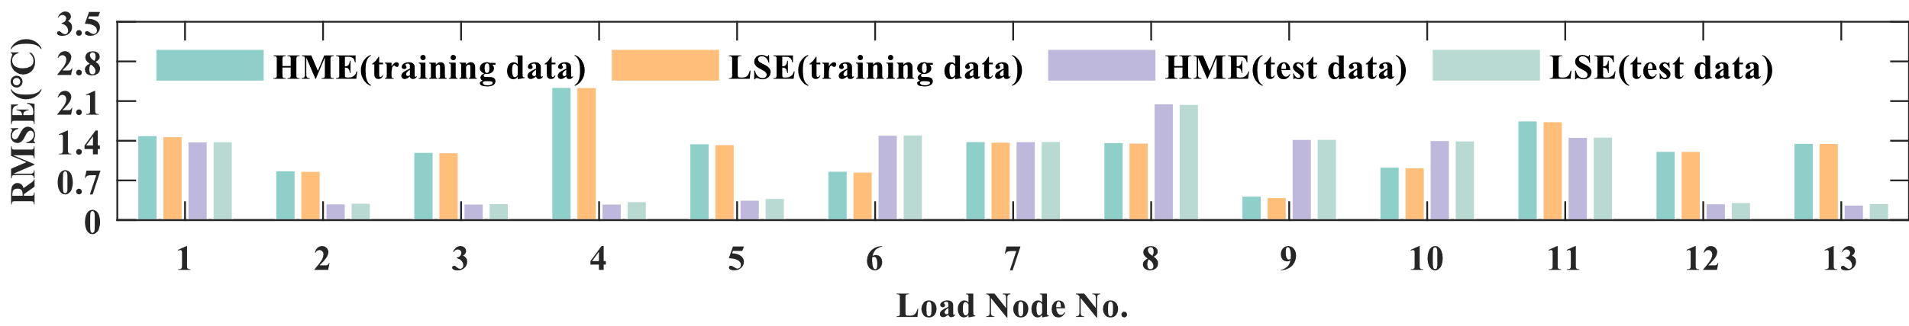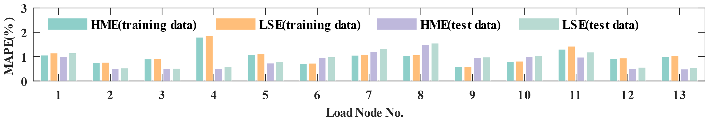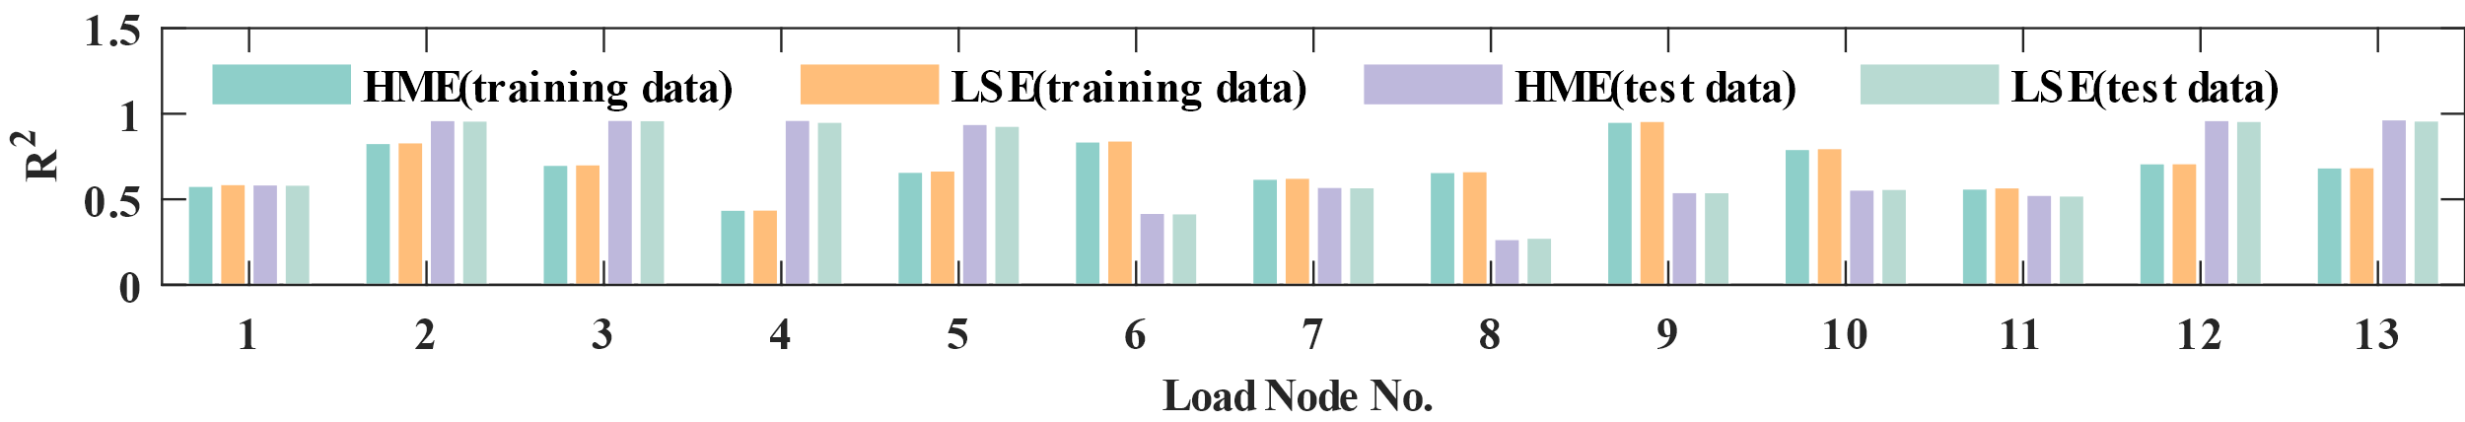

Fig. Goodness-of-fit metrics of the AGM in Case II.

## Data Comparison

The comparison between the real temperature and the AGM fitted temperature of each node is shown below. Obviously, the AGM can effectively filter outliers in real data and accurately display the trend of temperature changes.

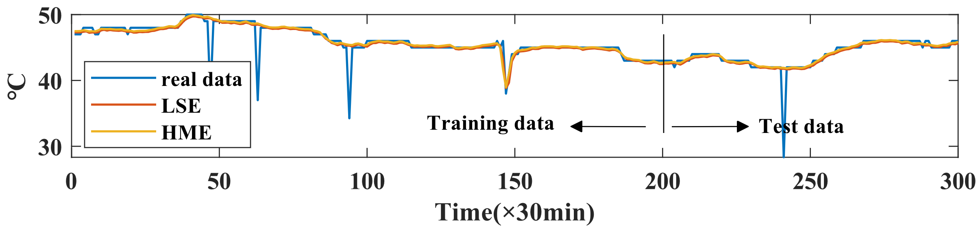

(a)

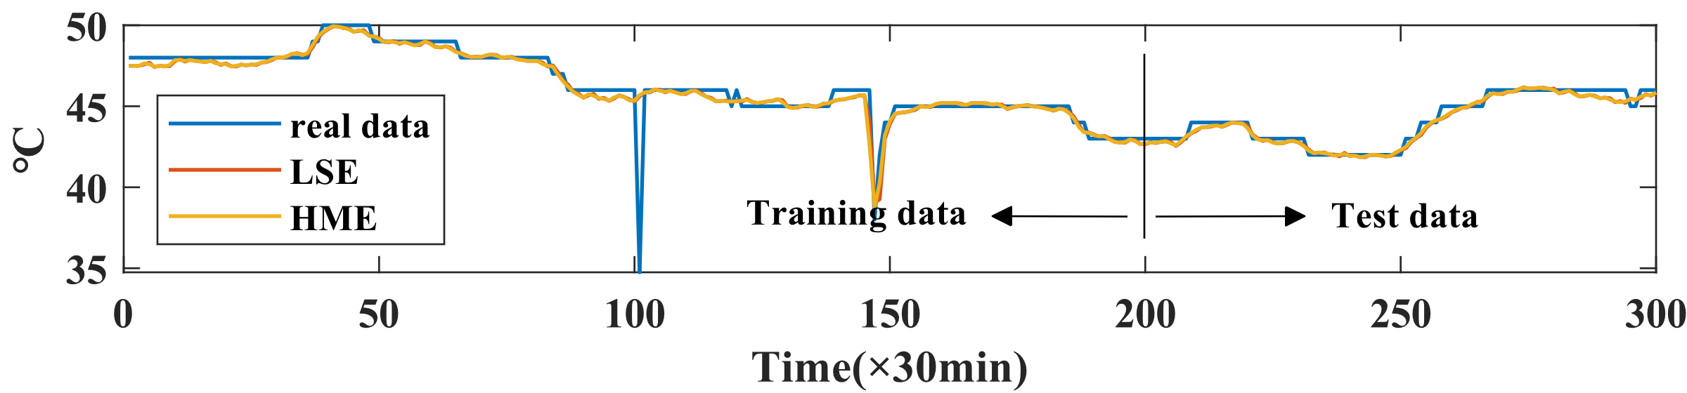

(b)

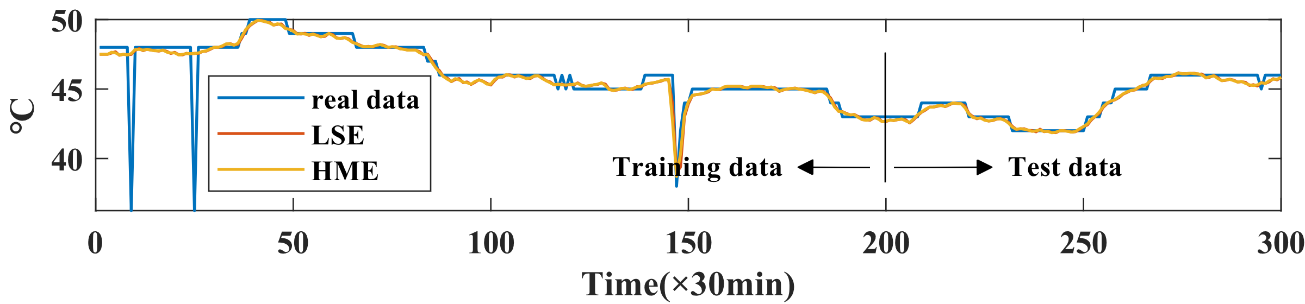

(c)

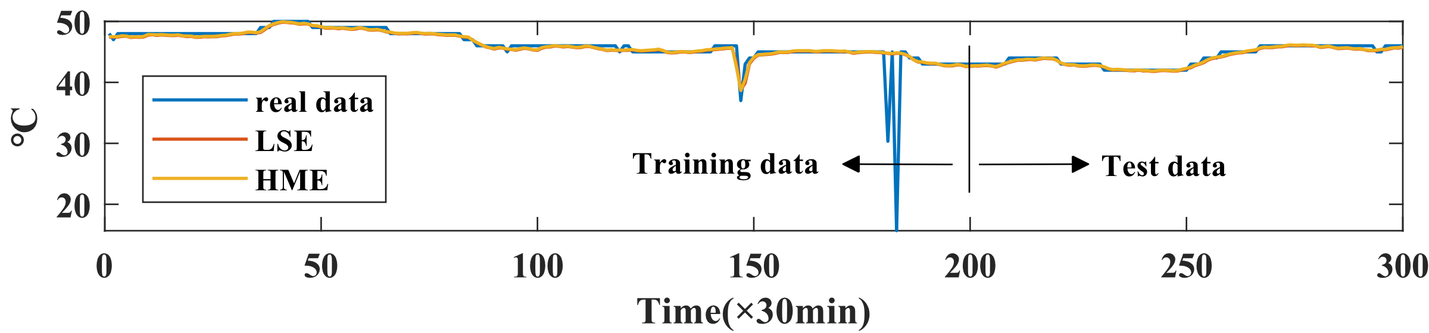

(d)

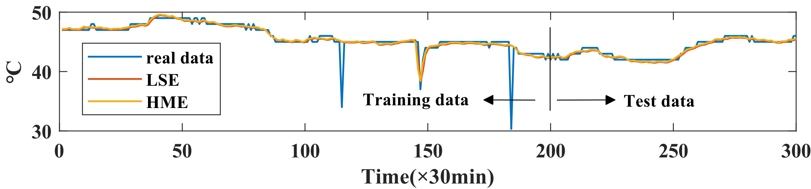

(e)

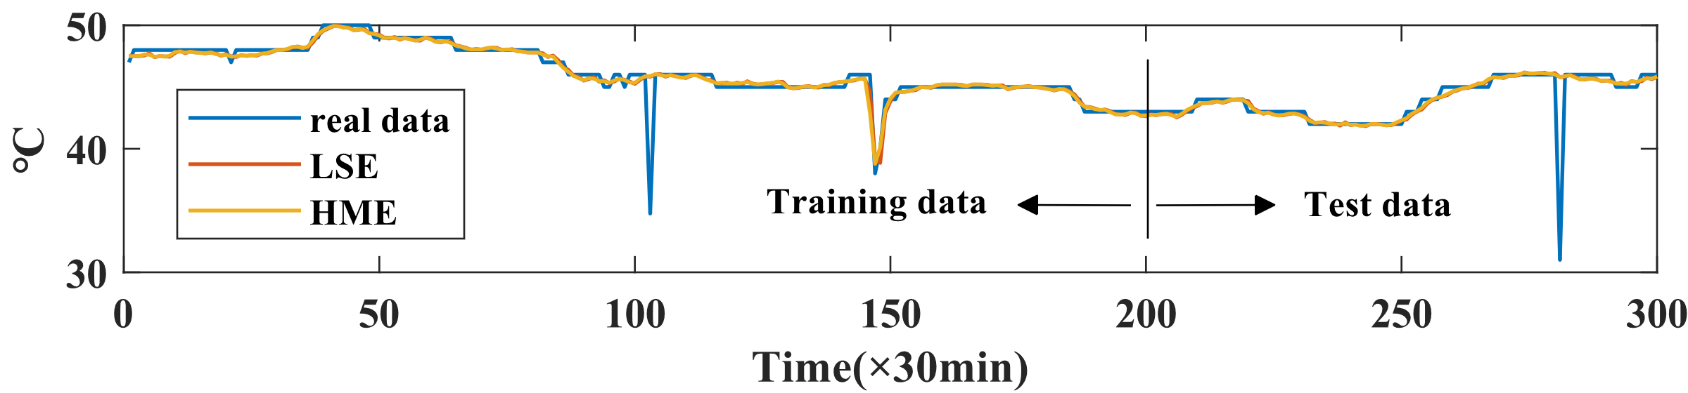

(f)

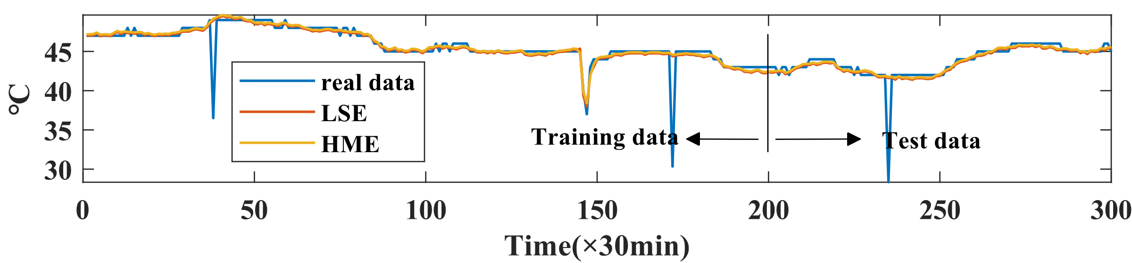

(g)

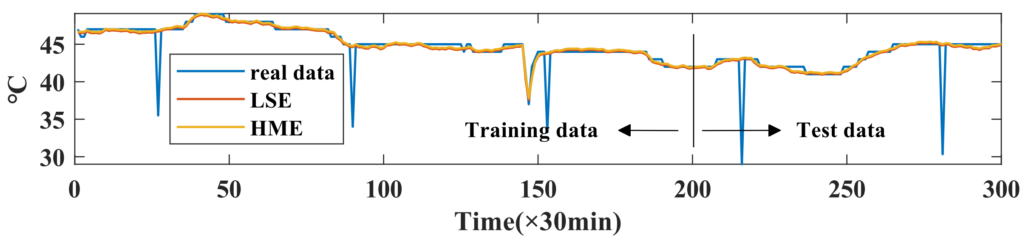

(h)

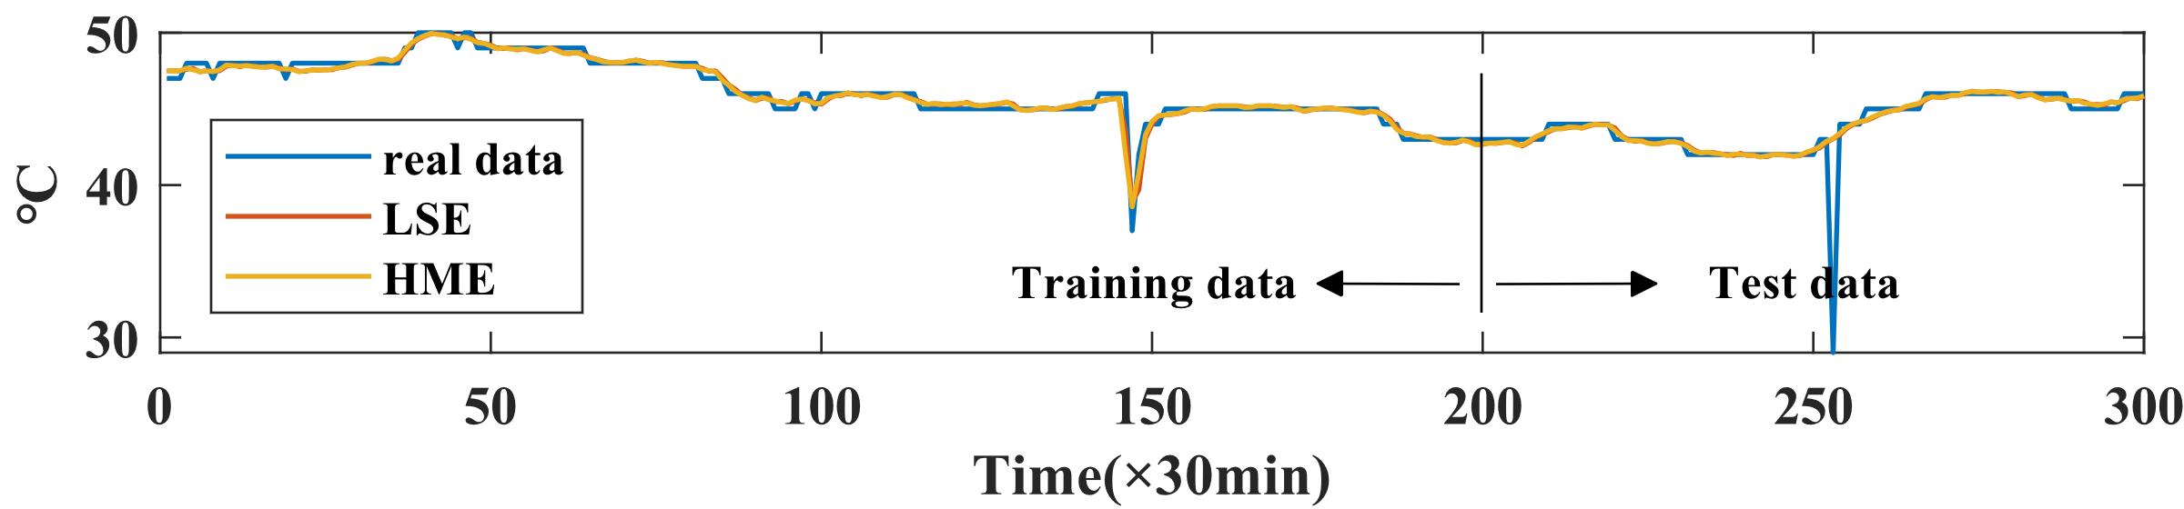

(i)

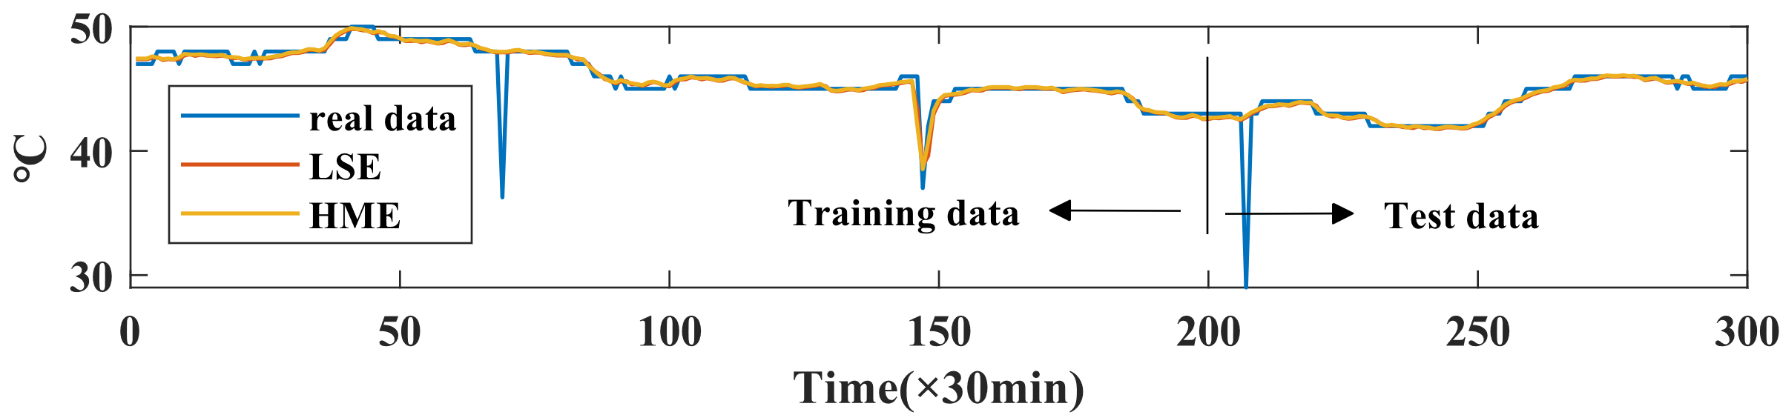

(j)

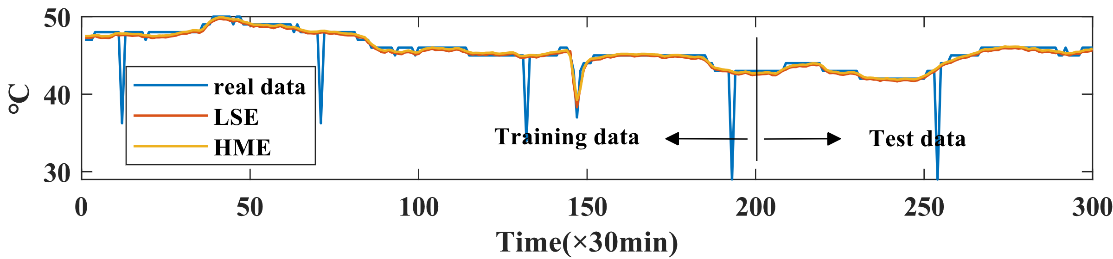

(k)

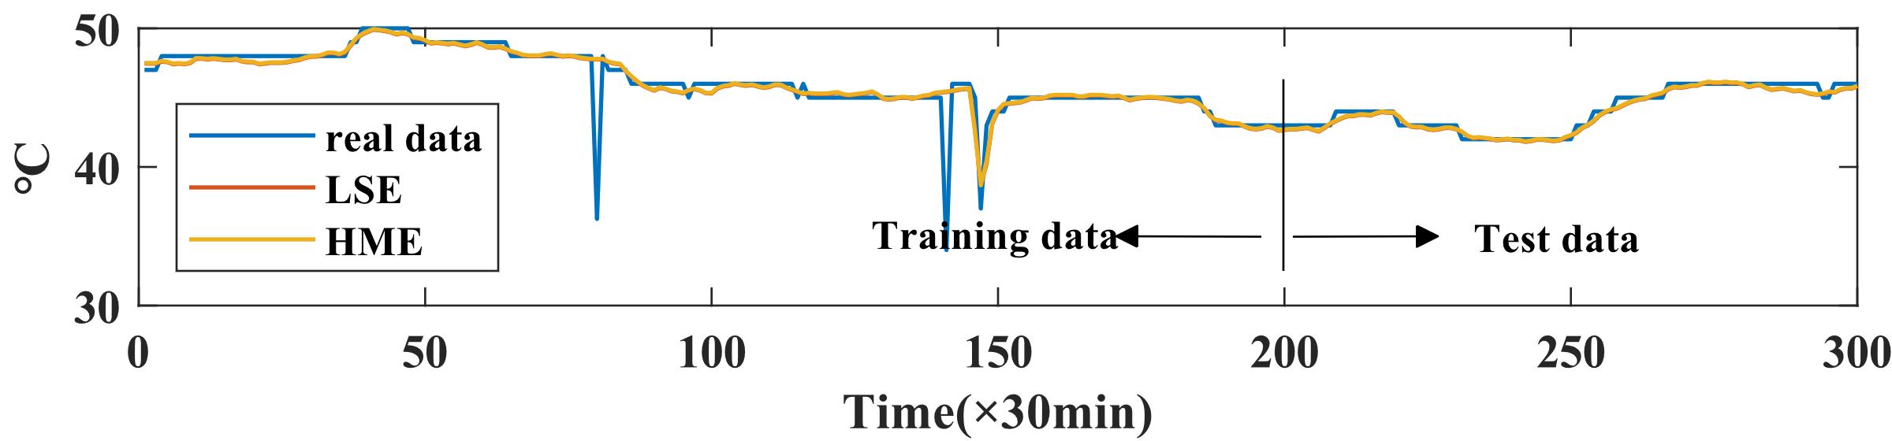

(l)

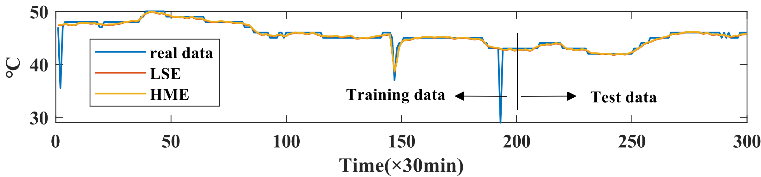

(m)

Fig. Temperature comparison